

**GRAPH DATABASE(NEO4J) CHARACTERISTICS**

**Team Members:**

**1.**17BCE0027- Priyanshu Mittal

**2.**17BCE0032-Diksha Singhania

**3.**17BCE0509-Divya Gahlot

**4.**17BCE0954-Achyut Tripathi

**INTRODUCTION.**

A graph database management system (henceforth, a graph database) is an online database management system with Create, Read, Update, and Delete (CRUD) methods that expose a graph data model. Graph databases are generally built for use with transactional (OLTP) systems. Accordingly, they are normally optimized for transactional performance, and engineered with transactional integrity and operational availability in mind.

A graph database provides a powerful but novel data modeling technique does not in itself provide sufficient justification for replacing a well-established, well-understood data platform; there must also be an immediate and very significant practical benefit. In the case of graph databases, this motivation exists in the form of a set of use cases and data patterns whose performance improves by one or more orders of magnitude when implemented in a graph, and whose latency is much lower compared to batch processing of aggregates. On top of this performance benefit, graph databases offer an extremely flexible data model, and a mode of delivery aligned with today’s agile software delivery practices.

### 1. Performance

One compelling reason, then, for choosing a graph database is the sheer performance increase when dealing with connected data versus relational databases and NOSQL stores. In contrast to relational databases, where join-intensive query performance deteriorates as the dataset gets bigger, with a graph database performance tends to remain relatively constant, even as the dataset grows. This is because queries are localized to a portion of the graph.

### 2. Flexibility

As developers and data architects we want to connect data as the domain dictates, thereby allowing structure and schema to emerge in tandem with our growing understanding of the problem space, rather than being imposed upfront, when we know least about the real shape and intricacies of the data. Graph databases address this want directly.

### 3. Agility

We want to be able to evolve our data model in step with the rest of our application, using a technology aligned with today’s incremental and iterative software delivery practices. Modern graph databases equip us to perform frictionless development and graceful systems maintenance. In particular, the schema-free nature of the graph data model, coupled with the testable nature of a graph database’s application programming interface (API) and query language, empower us to evolve an application in a controlled manner.

There are two **properties** of graph databases you should **consider when investigating graph database technologies**:

1. ***The underlying storage***

Some graph databases use *native graph storage* that is optimized and designed for storing and managing graphs. Not all graph database technologies use native graph storage, however. Some serialize the graph data into a relational database, an object-oriented database, or some other general-purpose data store.

1. ***The processing engine***

Some definitions require that a graph database use *index-free adjacency*, meaning that connected nodes physically “point” to each other in the database.[[3](https://www.oreilly.com/library/view/graph-databases/9781449356255/ch01.html#ftn.id654425)] Here we take a slightly broader view: any database that from the user’s perspective *behaves* like a graph database (i.e., exposes a graph data model through CRUD operations) qualifies as a graph database. We do acknowledge, however, the significant performance advantages of index-free adjacency, and therefore use the term *native graph processing* to describe graph databases that leverage index-free adjacency.

**CONCLUSION**

Property graphs capture complex domains in an expressive and flexible fashion, while graph databases make it easy to develop applications that manipulate our graph models.

**Screenshots**

**Code:**

**App.py**

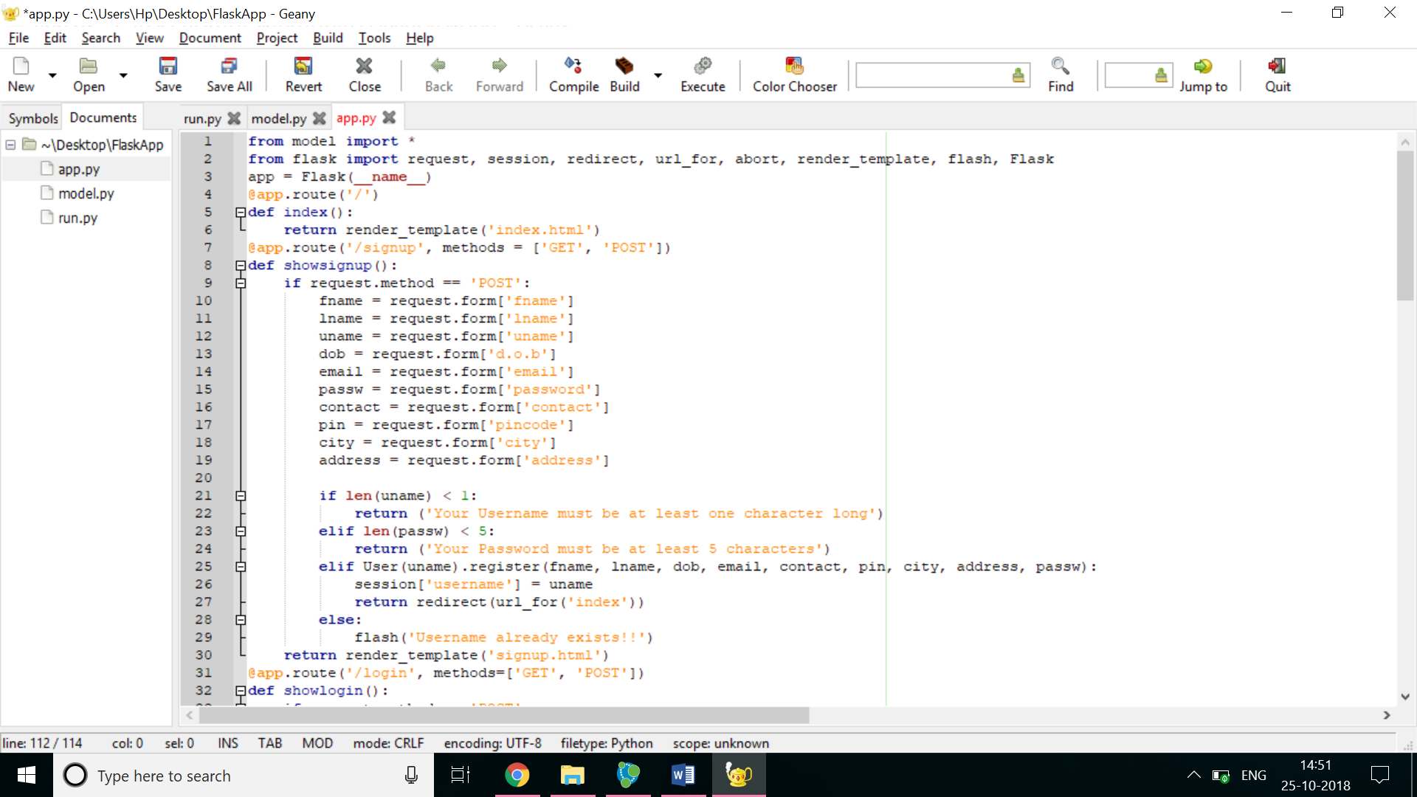

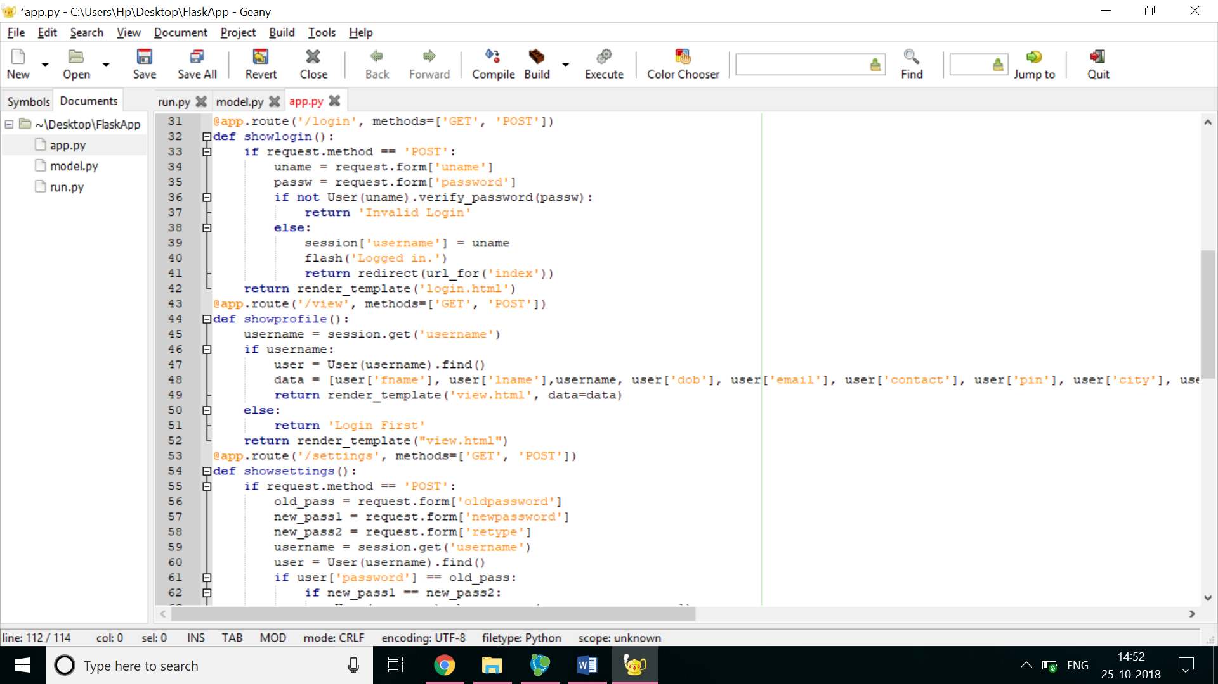

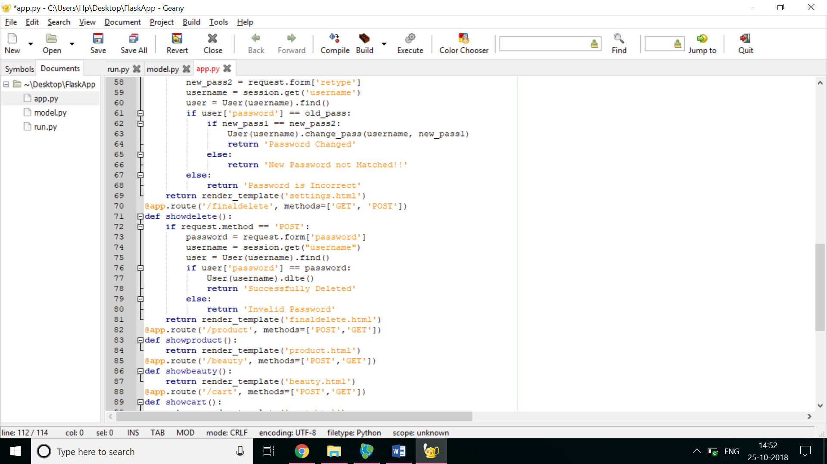

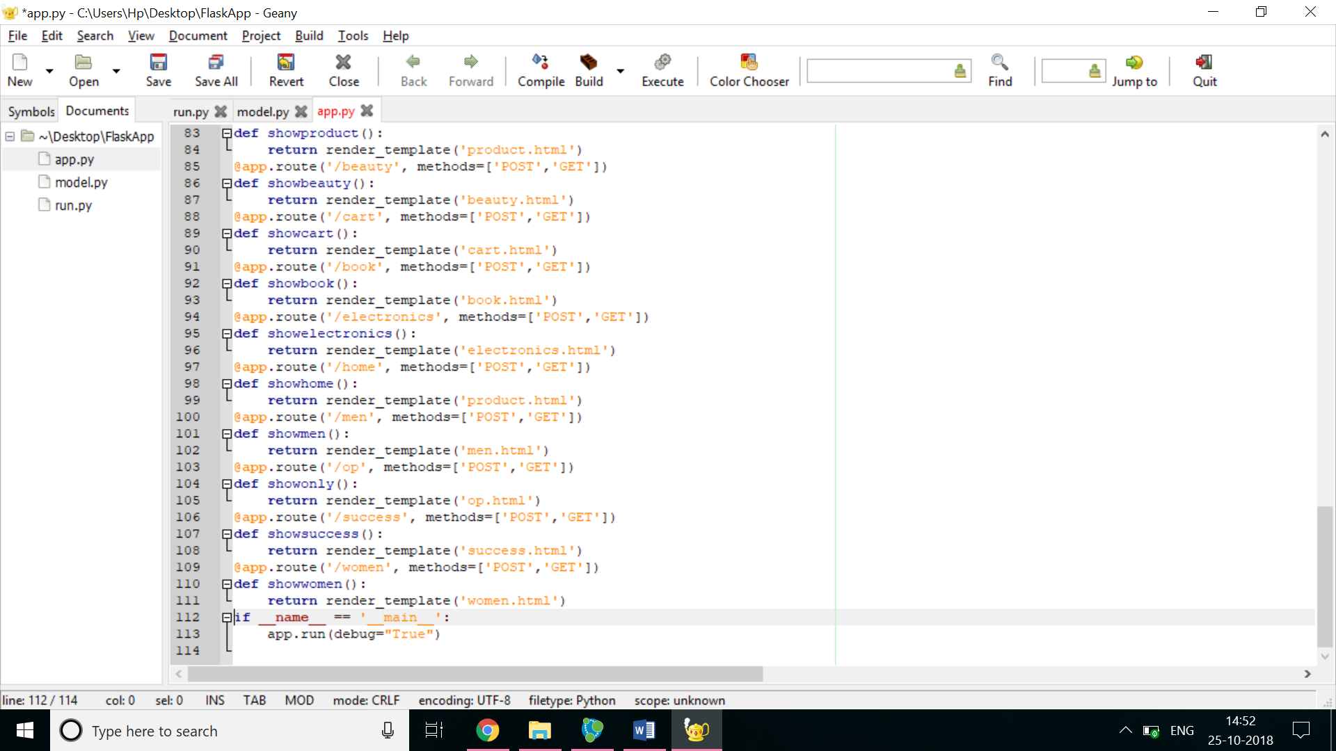

Model.py

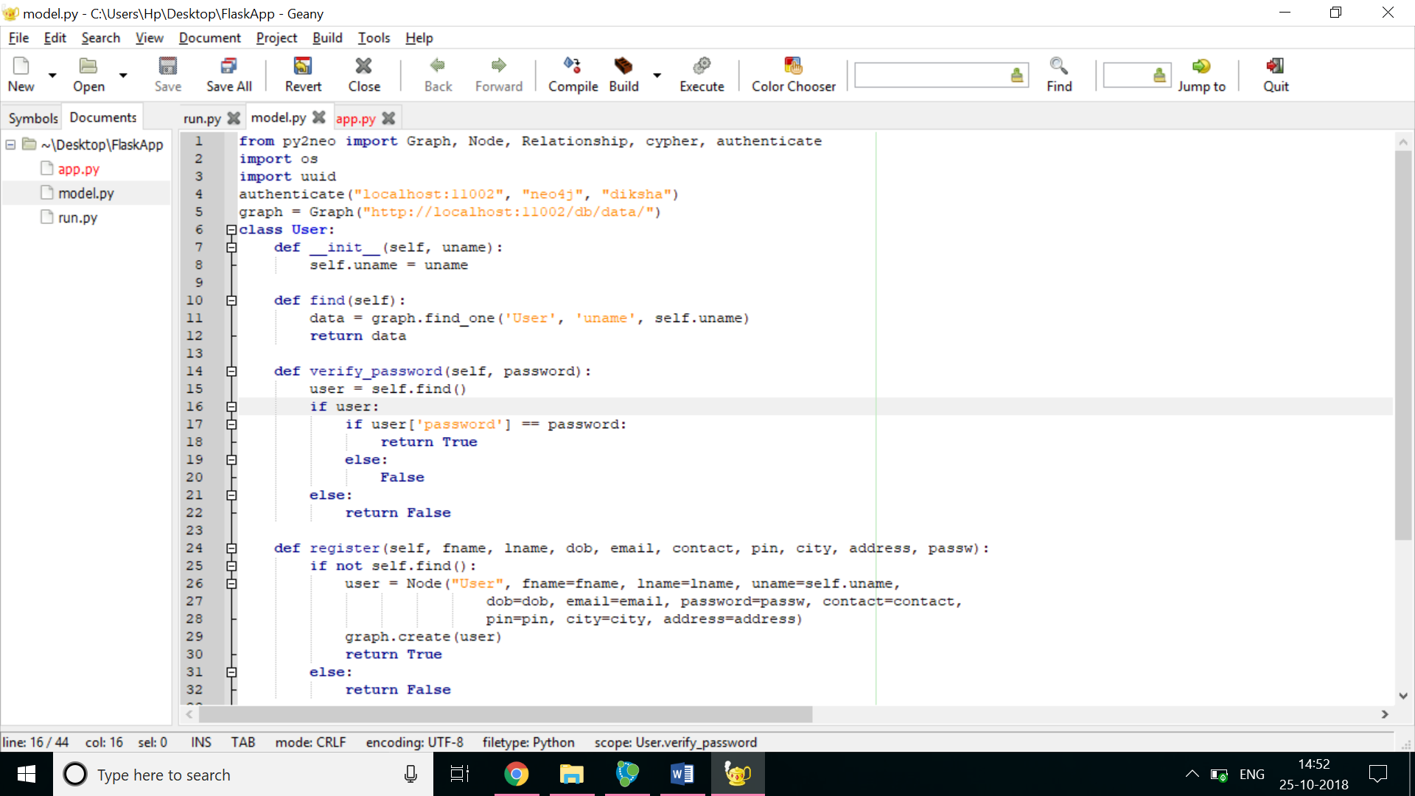

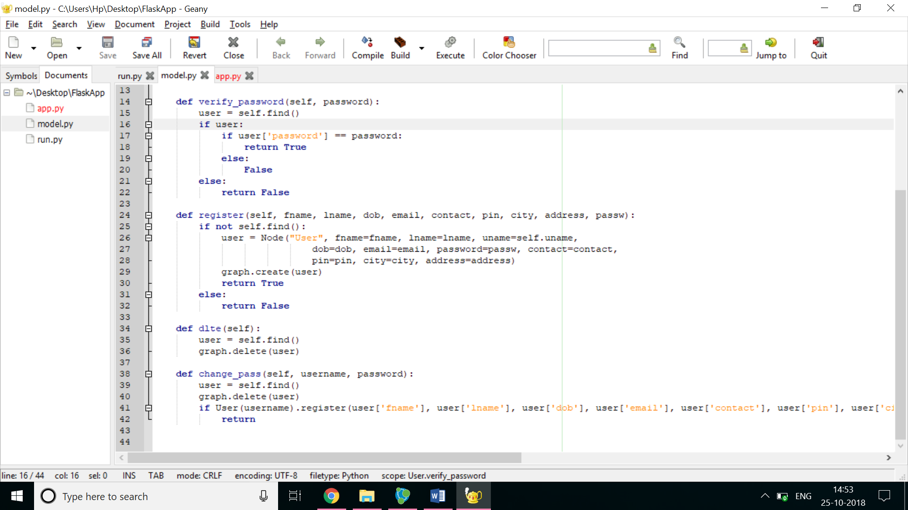

Run.py

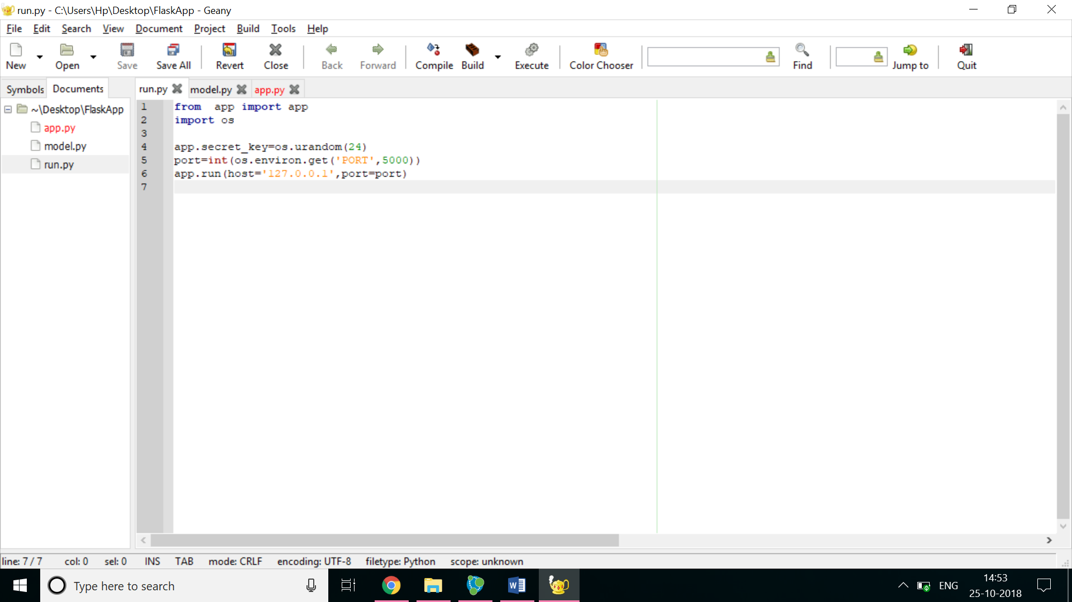

Frontend



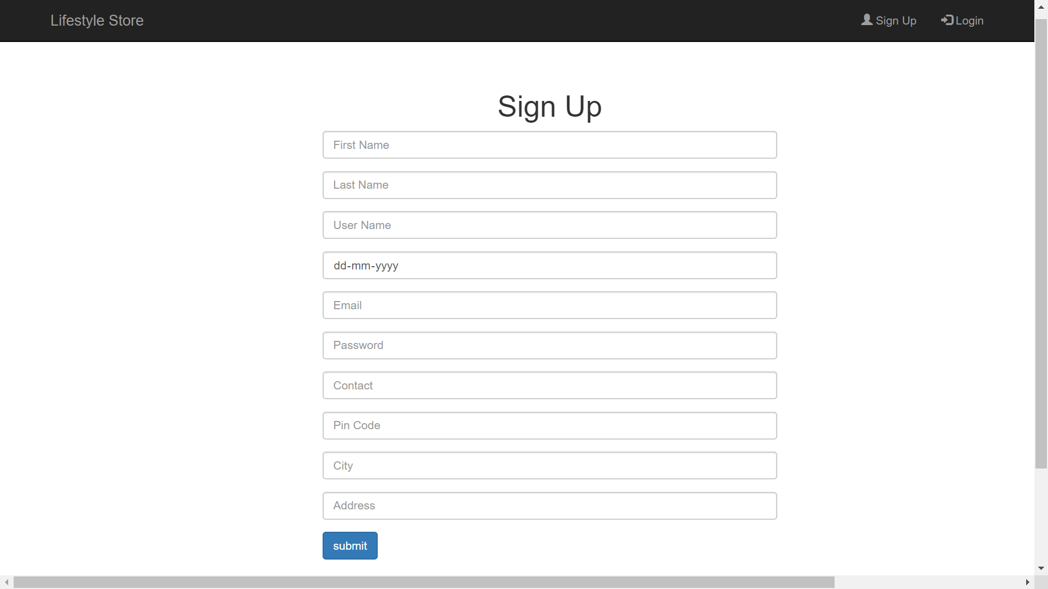

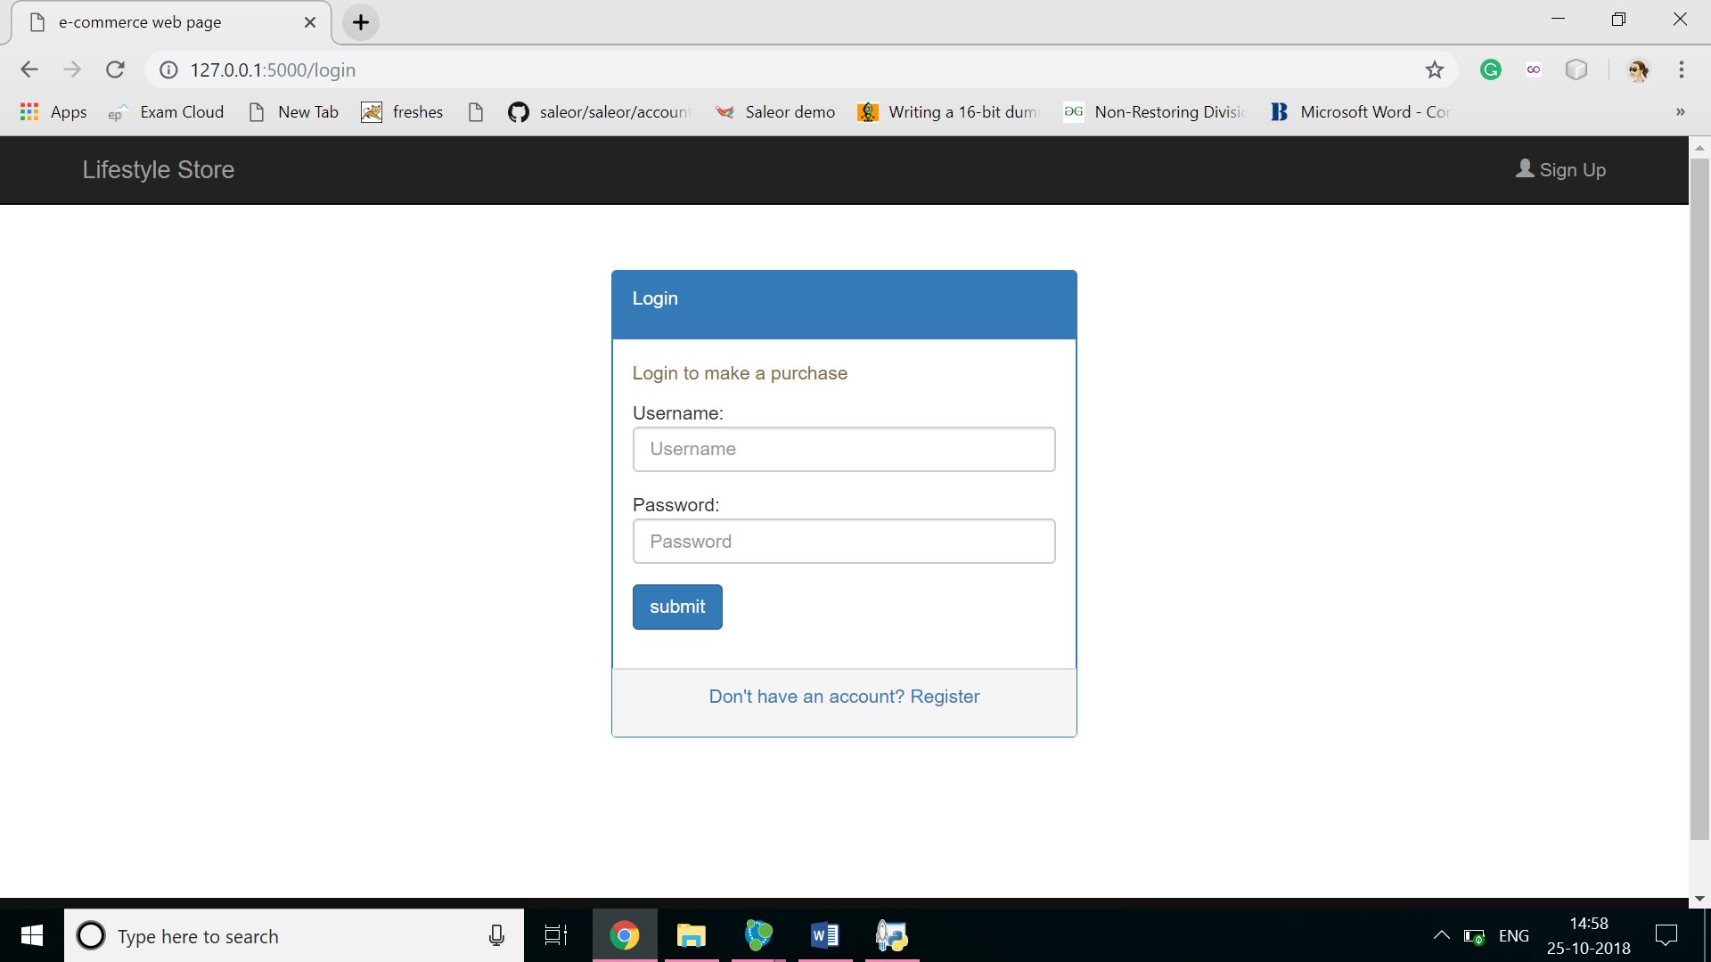

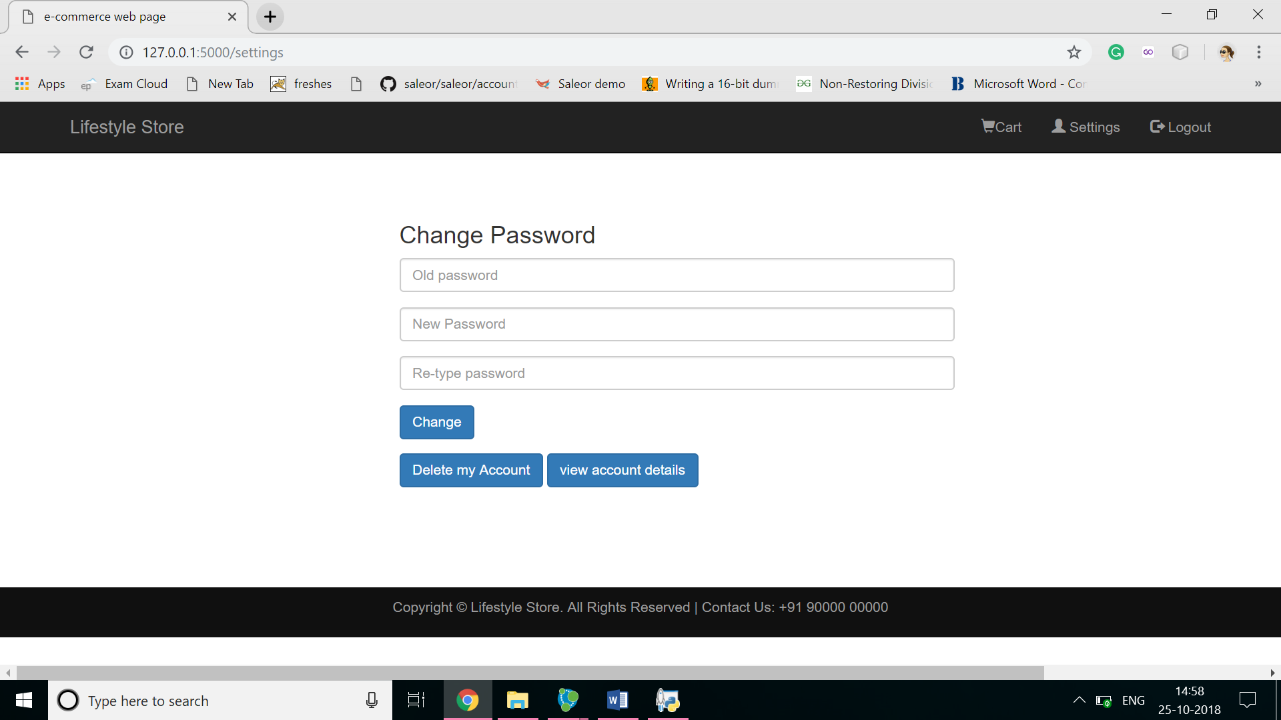

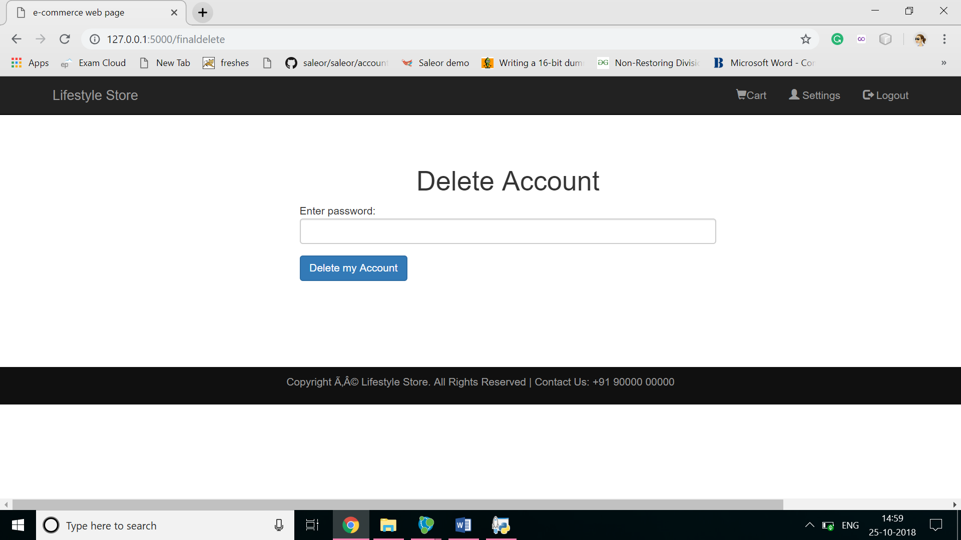

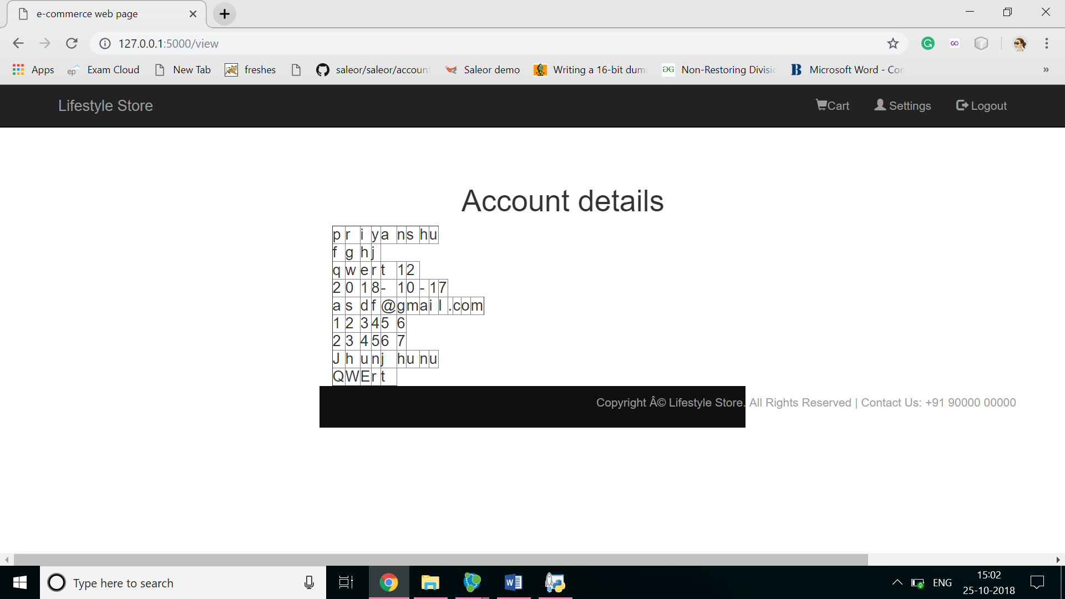



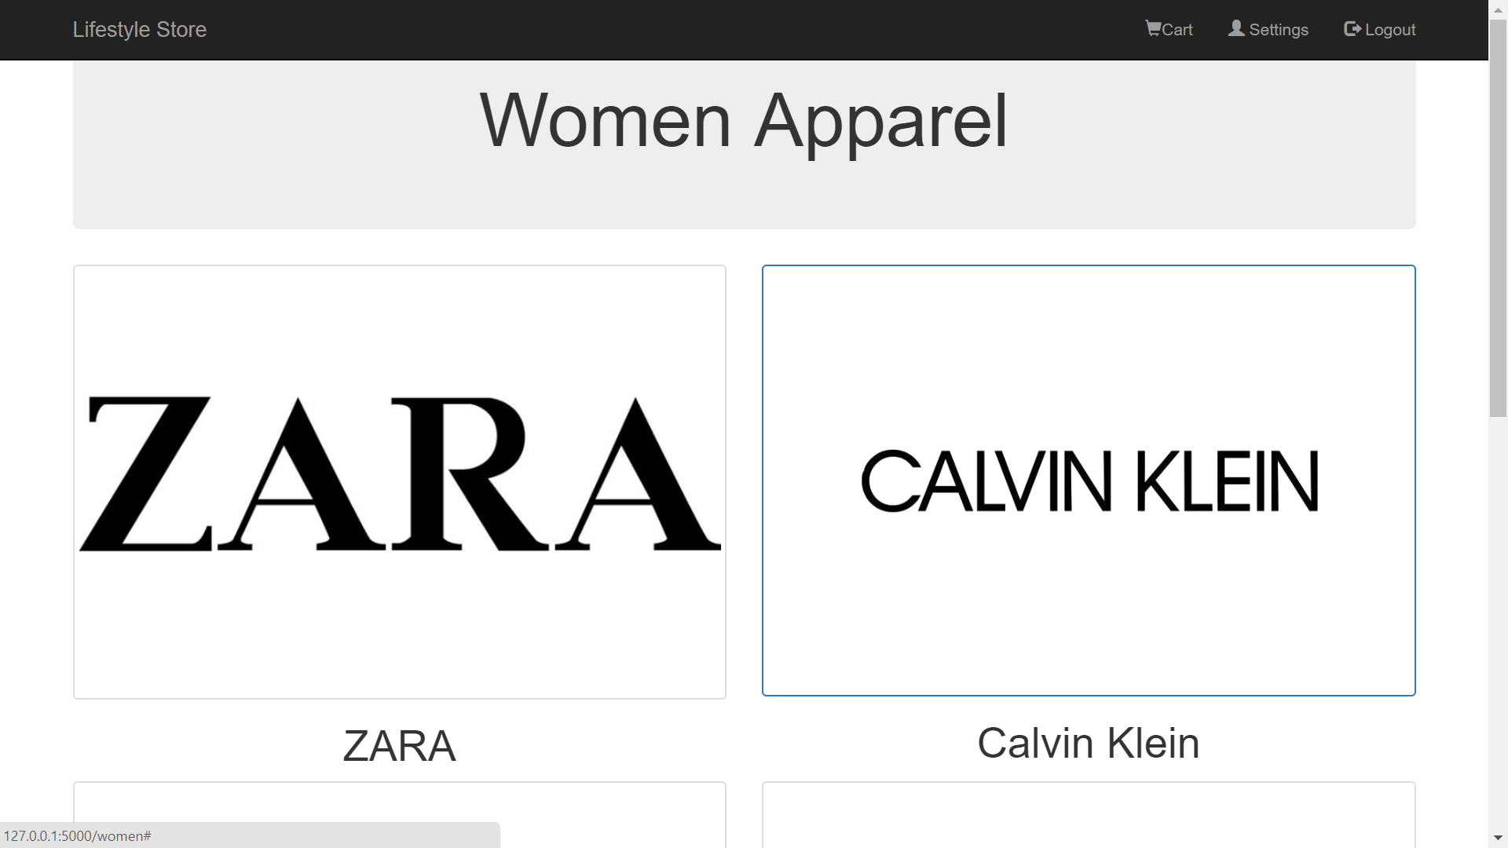

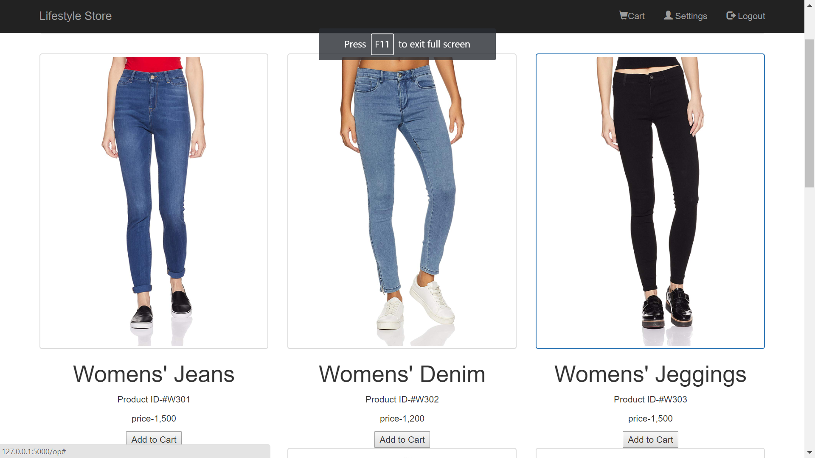

Database(neo4j)

